|  |  |  |  |
| --- | --- | --- | --- |
|  | Bansilal Ramnath Agarwal Charitable Trust's  Vishwakarma Institute of Information Technology  **Department of**  **Artificial Intelligence and Data Science** | | |
| Name: Siddhesh Dilip Khairnar | | | |
| Class: SY | Division: B | | Roll No: 272028 |
| Semester: IV | | Academic Year: 2022-2023 | |
| Subject Name & Code: Probability and Statistics: ES22201AD | | | |
| Title of Assignment: Installing R and basic operations and concepts in R | | | |

**PAS Experiment- 1**

**Installation of R**

1. Go to the [CRAN](https://cran.r-project.org/) website.
2. Click on **"Download R for Windows"**.
3. Click on **"install R for the first time"** link to download the R executable (.exe) file.
4. Run the R executable file to start installation and allow the app to make changes to your device.
5. Select the installation language.

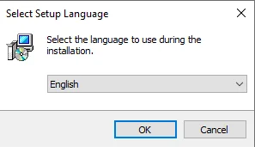

**Installing RStudio Desktop**

To install RStudio Desktop on your computer, do the following:

1. Go to the [RStudio](https://www.rstudio.com/) website.
2. Click on "DOWNLOAD" in the top-right corner.
3. Click on "DOWNLOAD" under the "RStudio Open-Source License".
4. Download RStudio Desktop recommended for your computer.
5. Run the RStudio Executable file (.exe) for Windows OS or the Apple Image Disk file (.dmg) for macOS X.

**Conclusion:** Thus, have installed R and performed operations using various data structures.